Ban the Box
& Establish Fair Chance Hiring Procedures for Public Employment with Wake County

In 2016, approximately 1,500 residents of Wake County will be released from prison and return to Wake County. These men and women will join more than 150,000 residents of Wake County with prior criminal justice involvement. A common experience among these community members is striving to be a productive, law-abiding citizen, only to be automatically excluded from gainful employment based on a negative criminal history. Such automatic exclusions are often based on minor, long-ago, or unrelated convictions that are not relevant to an applicant’s suitability for the job position. Rather than ensuring community safety, unnecessary exclusions based on superficially broad criteria deprive individuals—particularly men and women of color—the ability to provide for themselves and their families lawfully. Ultimately, this isolation from employment opportunities facilitates a revolving-door criminal justice system that drains community resources, undermines community safety, wastes human capital, and fails those who have paid their debts to society.

Have you ever been convicted of any unlawful offense, other than a minor traffic violation? ☒ Yes ☐ No

With almost 4,000 employees, Wake County Government is one of our community’s largest employers. Applicants for public employment with Wake County Government are asked the question above on the initial application for employment. There is no standardized procedure for the consideration of a criminal record to ensure an applicant is not prematurely excluded from employment based on his or her criminal record.

In order to restore opportunities for community members with criminal records to work hard, provide for their families, and contribute to our community—and, thereby, make Wake County more prosperous, more safe, and more fair—the Wake County Board of Commissioners should Ban the Box and establish Fair Chance Hiring procedures that ensure suitable candidates for public employment are not disqualified by minor, long-ago, or unrelated criminal convictions.

Recommended Reforms:

  - Eliminate the question regarding criminal convictions from Wake County Government’s application for employment;

  - Delay consideration of an applicant’s criminal record until the individual has been extended a conditional offer of employment and a criminal background check is conducted;

  - Identify uniform factors to be considered in reviewing an applicant’s criminal record to determine his or her suitability for the position, including (a) the nature and gravity of the offense; (b) the time elapsed since the offense; and (c) the nature of the job position;

  - Establish procedures that allow an applicant to (a) dispute the accuracy of a criminal record report, (b) contest the relevance of a conviction on his or her suitability for employment, and (c) submit evidence of rehabilitation.

Benefits of Establishing Fair Chance Hiring Procedures
“Of all the groups we targeted, people with records turned out to be the best employees, in part because they usually have a desire to create a better life for themselves…They are often highly motivated and many have usable job skills that are desirable for an employer. They come to work every day and do not engage in the type of behaviors that will land them back in the penal system.” -Terri Jackson, CEO
Wake County would join 19 states, the federal government, more than 100 cities and counties, and many national corporations in facilitating individualized reviews of applicants’ criminal records. The experiences of these communities and corporations demonstrate the many benefits of not prematurely excluding suitable candidates from employment based on superficial reviews of their criminal records.

- Better Employees: Fair Chance Hiring increases the pool of potential applicants and enhances an employer’s opportunity to hire the most suitable applicant. A study by Evolv found that workers with criminal records were more productive than workers without records.
- Improves Public Safety: A 2011 study of the formerly incarcerated found that employment was the single most important influence on decreasing recidivism, and that two years after release nearly twice as many employed people with records had avoided another brush with the law than their unemployed counterparts.
- Helps the Economy: North Carolina loses an estimated $1 billion in GDP annually due to the exclusion of individuals with criminal records from the work force. 3
- Benefits Children and Families: Parents excluded from jobs often have to rely on public assistance and are less able to financially support their children and other family members.
- Reduces Racial Disparities in Hiring: According to the Equal Employment Opportunity Commission and multiple sociological studies, hiring policies that exclude applicants based on superficial reviews of their criminal records disproportionately deprive African-American applicants of employment opportunities.

Bipartisan Support for Fair Chance Hiring Procedures
NC communities with Fair Chance Hiring Procedures:
- Charlotte
- Durham
- Durham County
- Fayetteville
- Cumberland County
- Spring Lake
- Carrboro
- Chapel Hill
- Asheville
- Greenville
Today, we are banning the box and ending employment discrimination. And this is going to make a huge difference for folks who have paid their debts to society, who want to start their lives over again and are going to have an opportunity to do just that in our state.
-Gov. Chris Christie (R)
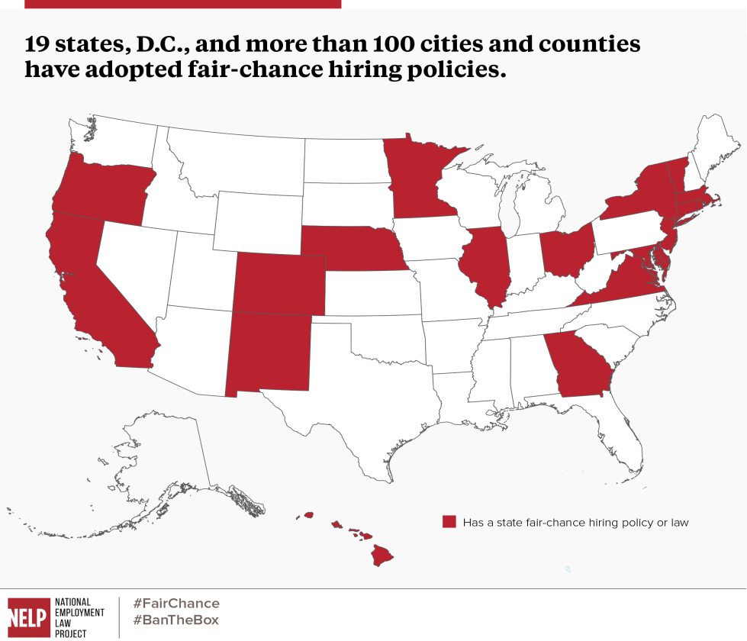

Ban the Box hiring policies enhance Georgia’s reputation as the number one place in which to do business by increasing qualified applicant pools and improving the likelihood that the employer will identify the best candidate for the position; and Georgia is positioned to enhance its reputation as regional leader by becoming the first state in the South to implement a fair hiring policy for applicants with criminal records. -Gov. Nathan Deal (R)

Has a state fair chance hiring policy or law
People shouldn’t be able to hide from their past, but they shouldn’t be shackled by it either. That’s why Ohio Gov. John Kasich did the right thing by ordering state agencies to stop requiring job seekers to disclose on their applications whether they have a prior criminal conviction.
-Editorial Board, Cleveland.com
The problem we’re trying to solve is not just to keep on catching people and putting them back in jail. The problem we’re trying to solve is giving people a foundation from which they can then become productive citizens. The goal is to prevent crime; the goal is to make sure that folks are fairly punished when they break the law. But the ultimate goal is to make sure that folks are law-abiding, self-sufficient, good citizens. And everything we do should be designed towards that goal. And if we’re doing a good job there, crime will go down and stay down.
-President Barack Obama

As a large United States-based manufacturing company that employs 60,000 American workers, we should not be rejecting people at the very start of the hiring process who may otherwise be capable and qualified, and want an opportunity to work hard.
-Mark Holden, Koch Industries
Because they’ve got to check that box, they never even get an interview for a job. So that’s a pretty small, little measure that says at least for federal employment and for federal contractors, we’re going to give those individuals a fair chance of at least getting an interview…It bridges the ideological divide in this country. As I said, we all want to see every American succeed.
-Sen. Ron Johnson (R- Wis), Senate Homeland Security and Governmental Affairs Comm.

“Wake County: Inmates Released from Prison & Community Supervised Population,” NC DPS Office of Research & Planning, http://randp.doc.state.nc.us/scripts/htmSQL.exe/docs/hsql/CS/COUNTY_STATS_MEMO.hsql
1 in 5 adults in North Carolina has a criminal record.
Laird, Lorelei, “Ex-Offenders face tens of thousands of legal restrictions, bias and limits on their rights,” ABA Journal, June 1, 2013.
John Schmitt and Kris Warner, “Ex-offenders and the Labor market,” Center for Economic and Policy research, 2010.
Megan Kurlychek, “Scarlet Letters and Recidivism: Does an Old Criminal Record Predict Future Offending,” March 2006, John Jay College.

