A CRIMINAL RECORD often gives rise to significant barriers to gainful employment, affordable housing, family unification, and a variety of other benefits and opportunities essential to productive citizenship. For assistance in understanding the statutory barriers to particular benefits or opportunities that may arise due to a specific criminal record, please use the UNC School of Government’s Collateral Consequences Assessment Tool at http://ccat.sog.unc.edu/.
In North Carolina, an expunction is the destruction of a criminal record by court order. An expunction (also called an “expungement”) of a criminal record restores the individual, in the view of the law, to the status he or she occupied before the criminal record existed. With rare exception, when an individual is granted an expunction, he or she may truthfully and without committing perjury or false statement deny or refuse to acknowledge that the criminal incident occurred. The primary exception to this is for purposes of federal immigration. Please see North Carolina General Statutes §15A-151 for other exceptions.
Prior to 2011, opportunities to expunge a criminal record in North Carolina were extremely limited. However, legislators have significantly expanded expunction opportunities over the last decade. As of December 1, 2020, criminal records eligible for expunction in North Carolina are generally limited to the following categories:
- A first-time conviction of a nonviolent felony
- One or multiple non-violent misdemeanor convictions
- A first-time conviction of certain drug offenses prior to age 22
- Any/all charges that are dismissed or disposed “not guilty”
- A conviction that was the result of being the victim of human trafficking.
This summary provides details of the following sixteen expunction statutes:
- Juvenile Record………………………………… NCGS §7B-3200 .…………… [p. 6]
- Misdemeanor Under Age 18…………………… NCGS §15A-145 ………..…… [p. 7]
- Gang Offense Under Age 18…………………… NCGS §15A-145.1…………... [p. 7]
- Controlled Substance Under Age 22 …………… NCGS §15A-145.2………….. [p. 8]
- Toxic Vapors Under Age 22……………............. NCGS §15A-145.3………….. [p. 9]
- Nonviolent Felony Under Age 18……….……… NCGS §15A-145.4………….. [p. 10]
- Nonviolent Offense…………………………...... NCGS §15A-145.5…………... [p. 11]
- Prostitution Offense………………………......... NCGS §15A-145.6…………... [p. 12]
- Cond. Discharge for Threat of Mass Violence….. NCGS §15A-145.7…................ [p. 12]
- Charge Remanded for Juvenile Adjudication…… NCGS §15A-145.8…………… [p. 12]
- “Raise the Age” Parity/Under 18 Convictions….. NCGS §15A-145.8A………… [p. 13]
- Certain Offenses by Human Trafficking Victim... NCGS § 15A-145.9……..……. [p. 13]
- Charge Resulting in Dismissal or Not Guilty ….. NCGS §15A-146…………….. [p. 14]
- Identity Theft and Mistaken Identity………….... NCGS §15A-147…………….. [p. 14]
- DNA Records………………………………....... NCGS §15A-148…………….. [p. 15]
- Pardon of Innocence……………………………. NCGS §15A-149…………….. [p. 15]
In addition, this summary provides the following information and resources:
- Overview of Recent Legislative Reforms ……………..……………………….…….... [pp. 4-5]
- Certificate of Relief……………………………. NCGS §15A-173……………… [p. 16]
- Indigent Fee Waiver ………………………………………………………………….. [p. 16]
- Petitioning for Expunction of a Criminal Record…………………………………… [p. 3]
- Eligibility Overview………………………………………………………………….. [p. 17]
- Reviewing a Criminal Record to Determine Expunction Eligibility: Decision Tree… [p. 17]
- Completing Form AOC-CR-281 Using a CIPRS Report…………………………….. [p. 18]
- How to Read an ACIS Criminal Record Report……………………………………….[p. 19]
- Petition for Expunction of Nonviolent Offense, Sample……………………………… [p. 20]
- Petition for Expunction of Dismissed Charges, Sample……………………………… [p. 21]
- Petitioner’s Affidavit, Worksheet…………………………………………………….. [p. 22]
- Petitioner’s Affidavit…………….……………………………………………………. [p. 23]
- Affidavit of Good Character, Worksheet……………………………………………… [p. 24]
- Affidavit of Good Character…………….…………………………………………….. [p. 25]
Also included in this summary are answers to questions regarding terms, interpretations, and procedures that frequently arise in petitioning for relief under North Carolina’s expunction laws. These frequently asked questions are located on pages 25 through 31.
The primary goal of this expunction guide is to increase access to expunction relief for North Carolinians with criminal records by providing members of the North Carolina bar with the information necessary to practice in this area of law. The vast majority of individuals actually eligible for expunction relief do not obtain it. The number of expunction orders in FY 2018/2019 is displayed below and startlingly small relative to the estimated 25 percent of adults in our state with a criminal record. If you are an attorney and find this guide helpful, I urge you to consider assisting low-income North Carolinians with pro bono or reduced-fee legal services (https://ncprobono.org/).

Table 1 NC Administrative office of the courts, 2019 Expunctions Report
Expunction Type | North Carolina General Statute | Expunctions Granted  FY 2018/2019 | Expunctions Granted  FY 2017/2018 | Expunctions Granted Since FY 2012/2013
Juvenile Record | 7B-3200 | 0 | 0 | 7
Misdemeanor Under Age 18 | 15A-145 | 137 | 177 | 1,140
Gang Offense Under Age 18 | 15A-145.1 | 1 | 0 | 3
Controlled Substance Dismissal Under Age 22 | 15A-145.2(a);  15A-145.2(b) | 111 | 95 | 560
Controlled Substance Conviction Under Age 22 | 15A-145.2(c) | 40 | 52 | 289
Toxic Vapor Dismissal Under Age 22 | 15A-145.3(a);  15A-145.3(b) | 31 | 34 | 144
Toxic Vapor Conviction Under 22 | 15A-145.3(c) | 2 | 4 | 12
Nonviolent Felony Under Age 18 | 15A-145.4 | 25 | 27 | 134
Nonviolent Offense at Any Age | 15A-145.5 | 1057 | 629 | 3,206
Prostitution Offense | 15A-145.6 | 4 | 0 | 9
Charge Not Resulting in Conviction | 15A-146 | 12,822 | 10,516 | 74,623
Identity Theft/Misidentification | 15A-147 | 1,308 | 833 | 3,731
Pardon of Innocence | 15A-149 | 0 | 0 | 3
Process of Petition-Based Expunction of a Criminal Record in North Carolina

Recent Key Legislative Changes to Expunction Eligibility and Procedure
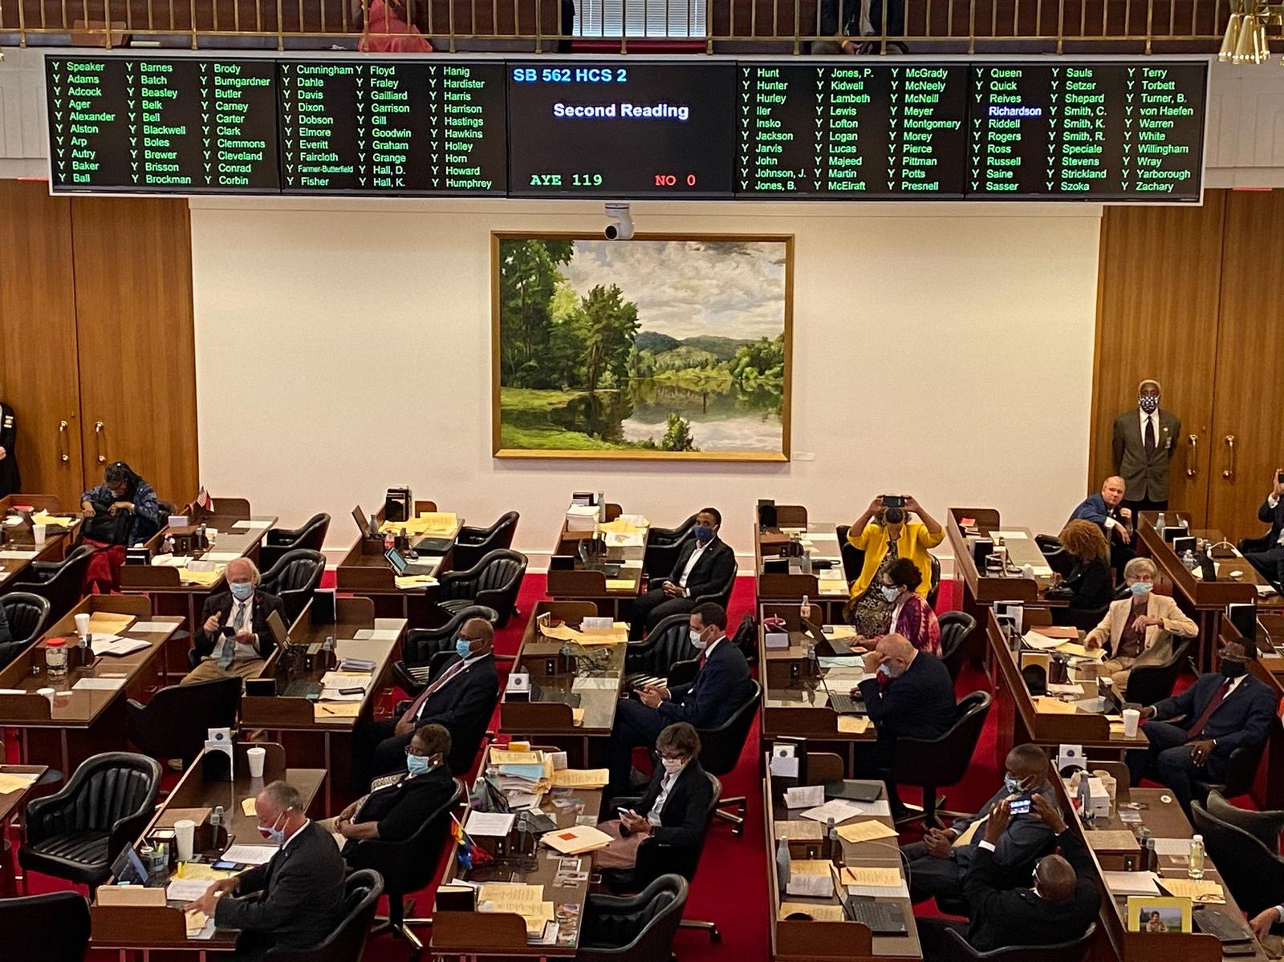
Session Law 2020-35 The Second Chance Act
On June 25, 2020, Governor Roy Cooper signed the Second Chance Act (S.L.2020-35) during a virtual signing ceremony. Senator Phil Berger (R-Rockingham) was a crucial supporter of the Second Chance Act along with the bill’s primary sponsors, Senator Danny Britt (R-Robeson, Columbus), Senator Warren Daniel (R-Avery, Burke, Caldwell), and former Senator Floyd McKissick (D-Durham). As outlined below, S.L. 2020-35 makes significant reforms to several expunction statutes. Unless otherwise noted, these changes to expunction eligibility and procedure apply to expunction petitions submitted on or after December 1, 2020. Details of these changes are provided in the relevant statute summaries and the next page. A good overview is also provided by the UNC School of Government here: https://nccriminallaw.sog.unc.edu/a-second-chance-in-north-carolina-through-expanded-criminal-record-clearance/.
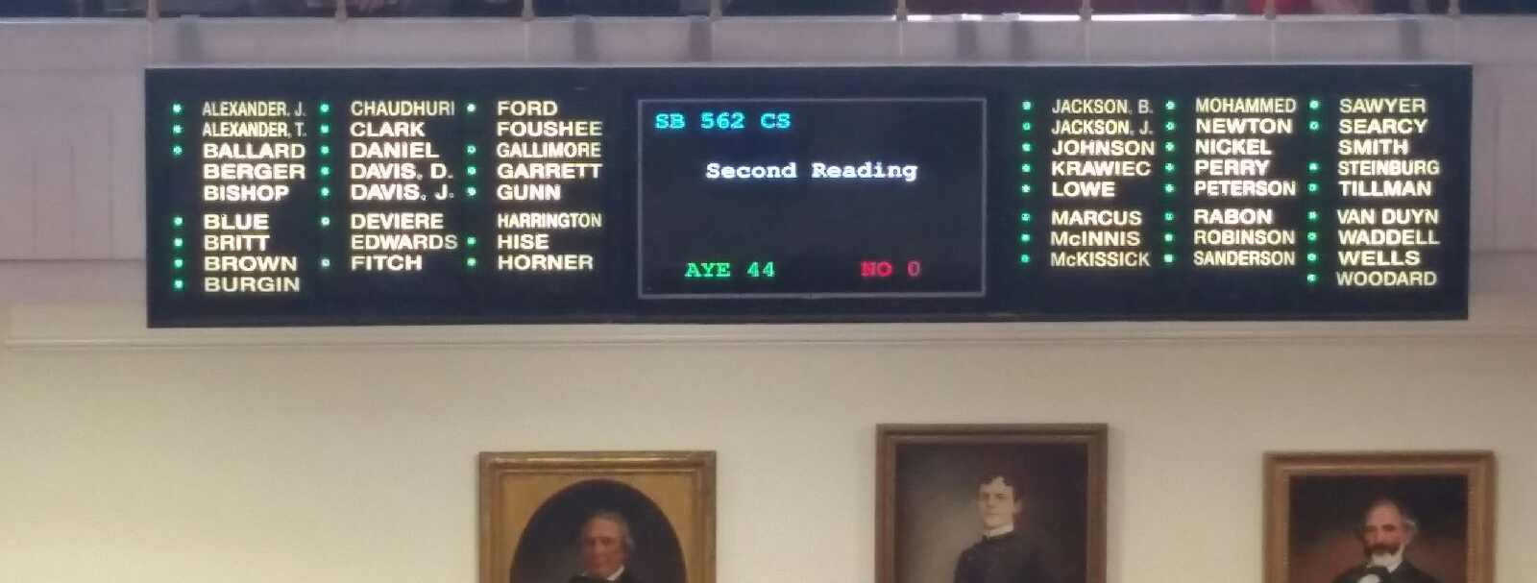
Session Law 2019-158 Human Trafficking Commission Recommendations Act
On December 1, 2019, Section 4(b) of S.L. 2019-158 took effect, extending expunction relief to individuals convicted of nonviolent offenses “if the court finds that the person was coerced or deceived into committing the offense as a direct result of having been a trafficking victim.” As of July 2020, no expunction order has been granted under this statute (according to the NC Administrative Office of the Courts), nor has anyone filed for relief despite the broad eligibility for relief.
Expanded Expunction Eligibility Under SCA
- Under Section 1 of the SCA, a person can expunge most misdemeanor or Class H or I felony convictions committed at age 16 or 17 and prior to December 1, 2019. Many legislators described this as “Raise the Age parity relief” and intended to make this relief as accessible as possible.
- Under Section 3 of the SCA, a person can expunge all dismissed and not guilty charges regardless of whether or not they have a felony conviction (effective December 1, 2020).
- Under Section 4 of the SCA, a person can expunge a first-time non-violent misdemeanor after 5 years; multiple non-violent misdemeanors after 7 years; and a first-time, non-violent felony after 10 years (effective December 1, 2020).
- Prosecutors have electronic access to all criminal records expunged after July 1, 2018 (the only exception to this are charges disposed “not guilty” and then expunged). These records may be used by a prosecutor:
  - To calculate prior record level and prior conviction level;
  - As a basis for indictment for a habitual offense;
  - When a conviction of a prior offense raises the offense level of a subsequent offense;
  - To determine eligibility for relief under GS 90-96(a); and when permissible under Rule 404(b) and rule 609.
- The SCA also states: “The expungement of a conviction shall not serve as a basis to challenge a conviction or sentence entered before the expungement of that conviction."

- Section 4(b) of Session Law 2019-158 The Human Trafficking Commission Recommendations Act provides that a person who has been convicted of one or multiple nonviolent offenses as a direct result of having been a human trafficking victim may petition to have the offense(s) expunged from their criminal record.

Improved Procedures Under SCA
- PROSECUTOR-INITIATED RELIEF: One of the most immediately impactful provisions of the Second Chance Act expands access to expunction relief by giving district attorneys the ability to initiate petitions for expunctions under GS 15A-145.9 (youthful convictions/raise the age parity relief) and 15A-146 (charges dismissed and disposed “not guilty”). Please see here for exciting news on prosecutor-initiated mass expunction initiatives underway:
  - https://www.ncjustice.org/thanks-to-bipartisan-second-chance-act-400000-convictions-eligible-for-prosecutor-initiated-expunctions/
  - District Attorney Jason Ramey (R-Rockingham, Caswell), who is filing petitions for expunction of more than 6,000 convictions, said, “These expunctions are simply the right thing to do. If the current law on juveniles were in place when these individuals were charged, there would be nothing to expunge because juvenile records are not public records. The legislature wisely raised the juvenile age to 18 because we now understand that the brains of juveniles are not fully developed, so they shouldn’t be forced to have lifelong consequences for irresponsible decisions made during their youth.”

- AUTOMATIC EXPUNCTION/“BY OPERATION OF LAW”: Under Section 3 of the SCA, charges dismissed on or after December 1, 2021—including felony charges, misdemeanors charges, and infractions--will be automatically expunged at disposition “by operation of law.” There is an exception to automatic expunction for certain charges dismissed pursuant to a plea agreement (but even in these circumstances, an individual would be eligible to petition for relief).

Expunction Type/ Statute | Criteria | Additional Information | Filing Requirements
Juvenile Record-Dismissal  NCGS 7B-3200(h) | - Alleged by juvenile petition to be delinquent or undisciplined juvenile;  - Juvenile petition was dismissed;  - Person has attained the age of:  - 16 years if alleged delinquent;  - 18 years if alleged undisciplined. | . | Petition Form: AOC-J-909M  Filing Fee: $0  Required Affidavits: None
Juvenile Record- Undisciplined  NCGS 7B-3200(a) | - Adjudicated undisciplined;  - Attained the age of 18 years;  - Good behavior since adjudication. |  | Petition Form: AOC-J-903M  Filing Fee: $0  Required Affidavits:  - Petitioner affidavit stating he/she has been of good behavior since the adjudication.  - ***Petition form (AOC-J-903M) serves as petitioner’s affidavit.  - 2 affidavits confirming good character from 2 individuals not related to client (or each other) who are familiar with the client’s reputation in the community  - See Form AOC-J-904M (affidavit of good character)
Juvenile Record- Delinquent  NCGS 7B-3200(b) | - Adjudicated delinquent;  - At least 18 years old;  - Offense for which the person was adjudicated would NOT have been a Class A, B1, B2, C, D, or E felony if committed by an adult;  - At least 18 months have elapsed since petitioner was released from juvenile court jurisdiction;  - Not subsequently adjudicated delinquent;  - Not convicted as an adult of any felony or misdemeanor, other than a traffic violation. |  | Petition Form: AOC-J-903M  Filing Fee: $0  Required Affidavits:  - Petitioner affidavit stating:  - Good behavior since adjudication.  - Has not subsequently been adjudicated delinquent; and has not been convicted of a felony or misdemeanor  - Petition form (AOC-J-903M) serves as petitioner’s affidavit.  - 2 affidavits confirming good character from 2 individuals not related to client (or each other) who are familiar with the clients reputation in the community  - See Form AOC-J-904M (affidavit of good character)

Expunction Type/ Statute | Criteria | Additional Information | Filing Requirements
Misdemeanor  Under 18  NCGS 15A-145 | 1. Misdemeanor conviction committed before age 18 OR misdemeanor possession of alcohol (18b-302(b)(1)) committed before age 21  - Both violent and nonviolent misdemeanors are eligible. The only ineligible misdemeanor offense is impaired driving under G.S. 20-4.01(24a)*  2. No previous misdemeanor or felony convictions, other than traffic violations.  3. No subsequent misdemeanor or felony convictions, other than traffic violations, within 2 year waiting period.  4. At least 2 years have passed since the date of conviction.  5. The individual has fully completed his or her sentence | Relief is mandatory. If petitioner is eligible for expunction, the court is required to provide it.  *This exception went into effect on Dec. 1, 2015 (see S.L. 2015-150).  Unclear whether multiple misdemeanor convictions occurring in the same session of court may be treated as single conviction. According to an old AG’s opinion, multiple convictions occurring in the same session of court may not be treated as single conviction. However, based on the text of other expunction statutes, courts typically expunge multiple misdemeanor conviction occurring in the same session of court.  Having previously been granted an expunction does not make the petitioner explicitly ineligible for expunction under 15A-145. | Form: AOC-CR-286  Cost: $175 (but may file indigent fee waiver)  Required Affidavits:  - Petitioner affidavit stating:  - Has been on good behavior for the 2-year waiting period and has not been convicted of any felony or misdemeanor other than a traffic violation.  - Petition is a motion in the cause in the case wherein the petitioner was convicted.  - No restitution orders or civil judgments representing amounts ordered for restitution against him are outstanding.  - 2 affidavits confirming good character from 2 individuals not related to client (or each other) who are familiar with the clients reputation in the community.  Notice: petition must be served on DA.
Gang Offense  Under 18  NCGS 15A-145.1 | - Conviction for a Class H felony under Article 13A, Chapter 14, OR an offense for which punishment was enhanced pursuant to GS 14-50.22.  - No previous felony or misdemeanor convictions other than a traffic violation  - Date of offense was prior to petitioner’s 18th b’day.  - At least 2 years have passed since conviction.  - Petitioner has completed all terms of sentence.  - No felony or misdemeanor convictions other than traffic offenses for two years from the date of conviction.  - No outstanding restitution or civil judgments representing amounts ordered for restitution. | Under this same statute, you can also have a gang-related charge that was dismissed pursuant to NCGS 14-50.29 expunged if criteria identical to expungement of a gang conviction are satisfied. | Form: AOC-CR-269  Cost: $175 (but may file indigent fee waiver)  Required Affidavits:  - Petitioner affidavit stating:  - Has been on good behavior for the 2-year waiting period and has not been convicted of any felony or misdemeanor other than a traffic violation.  - Petition is a motion in the cause in the case wherein the petitioner was convicted.  - No restitution orders or civil judgments representing amounts ordered for restitution against him are outstanding.  - 2 affidavits confirming good character from 2 individuals not related to client (or each other) who are familiar with the clients reputation in the community.  Petition must be served on DA.
Expunction Type/ Statute | Criteria | Additional Information | Filing Requirements
Dismissed Drug Charge  Under Age 22  NCGS 15A-145.2(a) | 1. Charge dismissed under G.S. 90-96(a) or (a1) diversionary program.  2. Not over 21 years of age at time of offense.* | *There is a significant discrepancy here. Statute only seems to require the 2 conditions listed here for eligibility. However, statute also requires affidavit stating that petitioner has no other convictions. If that’s the case, then much more narrow than 15A-146—and so the only time to use this is if one has already received expunction under 15A-146. | Form: AOC-CR-266  Cost: $175 (unclear if can file indigent waiver)  Required Affidavits: Petitioner affidavit stating has not been convicted of any other conviction. Affidavits of 2 others attesting to good reputation.
Dismissed Drug Charge  Under Age 22  NCGS 15A-145.2(b) | - Charge dismissed or finding of not guilty;  - Misdemeanor charge under Art 5, Chap 90  - Felony charge under 90-95(a)(3)  - Prior to 2012, less than1 gram of cocaine  - 2012 and beyond, a controlled substance  - Not over 21 years of age at time of offense. |  | Form: AOC-CR-266  Cost: $175 (unclear if you can file indigent fee waiver)  Required Affidavits: none
Drug Conviction Under Age 22  NCGS 15A-145.2(c) | - Conviction for:  - Misdemeanor Drug Possession (under Chapter 90, Article 5);  - Misdemeanor Drug Paraphernalia (under GS 90-113.22); OR  - Felony Possession under GS 90-95(a)(3)*  - At least 12 months have passed since the date of conviction.  - Petitioner was not over the age of 21 at the time of the offense.  - Petitioner has either successfully completed drug program or will ask the court to waive this requirement.  - Petitioner has no other felony conviction, misdemeanor conviction under Chapter 90, or any conviction related to controlled substances. **  - No prior expunction under 15A-145.2(c). | Silent as to whether multiple convictions occurring in same session of court may be treated as single conviction for expunction purposes.  Judge may waive the drug education program requirement in extenuating circumstances.  *According to AOC’s interpretation, individuals convicted of felony possession under GS 90-95(a)(3) prior to 2012 are only eligible for expunction under this statute if the offense involved less than 1 gram of cocaine. Those convicted of felony possession under GS 90-95(a)(3) in 2012 and beyond are eligible for expunction no matter the quantity or the specific controlled substance. The basis of this interpretation is not captured within the text of the statute; instead it is based on a strict textual interpretation of the “effective date” provision of Section 5 of the Justice Reinvestment Act. Specifically, Section 5.(e) reads: “This section becomes effective January 1, 2012, and applies to persons entering a plea or who are found guilty of an offense on or after that date.”  There is an argument to be made that the provision was focused on the portions of Section 5 that expanded eligibility for conditional discharge of first offenses and established advanced supervised release, and was not intended to deprive otherwise eligible individuals of expunction relief. | Form: AOC-CR-266  Cost: $175 (but may file indigent status fee waiver)  Required Affidavits: None  **AOC has interpreted the statute to require that the petitioner have no other misdemeanor or felony convictions in order to receive an expunction under this statute. Based on the construction of the statute, there is a reasonable argument that this is an erroneous interpretation and that someone with a subsequent misdemeanor conviction unrelated to controlled substances would still be eligible for expunction. For guidance on “may” v. “shall” ambiguity see In Re Expungement for Spencer, 140 N.C. App. 776 (2000).  ***I have successfully persuaded courts to interpret the “may” as providing the court discretion to expunge a first-time drug conviction where an individual has a subsequent non-drug misdemeanor conviction
Expunction Type/ Statute | Criteria | Additional Information | Filing Requirements
Dismissed Charge Toxic Vapors/Drug Paraphernalia Charge Under 22  NCGS 15A-145.3(a) | - Charge dismissed under G.S. 90-113.14(a) or (a1) diversionary program.  - Not over 21 years of age at time of offense.* | *There is a significant discrepancy here. Statute only seems to require the 2 conditions listed here for eligibility. However, statute also requires affidavit stating that petitioner has no other convictions. If that’s the case, then much more narrow than §15A-146—and so the only time to use this is if petitioner has previous expunction under §15A-146. | Form: AOC-CR-268  Cost: $175 (unclear if you can file for indigent fee waiver)  Required Affidavits: Petitioner affidavit stating has not been convicted of any other conviction. Affidavits of 2 others attesting to good reputation.
Dismissed Charge Toxic Vapors/Drug Paraphernalia Charge Under 22  NCGS 15A-145.3(b) | - Misdemeanor charge:  - Under Article 5A, Chapter 90  - For possession of drug paraphernalia under GS 90-113.22  - Charge dismissed or finding of not guilty;  - Not over 21 years of age at time of offense. |  | Form: AOC-CR-268  Cost: $175 (unclear whether you can file for indigent fee waiver)  Required Affidavits: none
Toxic Vapors/Drug Paraphernalia Conviction Under Age 22  NCGS 15A-145.3(c) | - Misdemeanor conviction under Chapter 90, Article 5A.  - At least 12 months have passed since the date of conviction.  - Petitioner was not over the age of 21 at the time of the offense.  - Petitioner has either successfully completed drug program or will ask the court to waive this requirement.  - Petitioner has no other conviction under Articles 5, 5A, or 5B of Chapter 90, or any other conviction related to controlled substances. **  - No prior expunction under 15A-145.3(c). | Silent as to whether multiple convictions occurring in same session of court may be treated as single conviction for expunction purposes.  Judge may waive the drug education program requirement in extenuating circumstances.  **AOC has interpreted the statute to require that the petitioner have no other misdemeanor or felony convictions in order to receive an expunction under this statute. Based on the construction of the statute (use of “may” and “shall”), there is a reasonable argument that this is an erroneous interpretation and that someone with subsequent misdemeanor convictions not related to controlled substances may be eligible for expunction under this statute. | Form: AOC-CR-268  Cost: $175 (unclear if you can file for indigent fee waiver)  Required Affidavits: None
Expunction Type/ Statute | Criteria | Additional Information | Filing Requirements
Nonviolent Felony Under 18  NCGS 15A-145.4 | - Conviction of a nonviolent felony*  - Multiple felonies may be treated as one conviction ONLY if convictions occurred in the same session of court.  - Date of offense for felony conviction was prior to 18th b’day.  - No prior misdemeanor or felony convictions, other than traffic violations. (see FAQ 9)  - No subsequent misdemeanor or felony convictions, other than traffic violations, within 4 year waiting period.  - At least 4 years have passed since the date of conviction.  - The individual has fully completed his or her sentence (incl. probation)  - The petitioner has no outstanding warrants or pending criminal cases  - No previous expunction.  - Petitioner has performed 100 hours of community service since conviction and has a HS diploma or GED. | *The term nonviolent misdemeanor or nonviolent felony means any misdemeanor or felony EXCEPT:  - a Class A - G felony or a Class A1 misdemeanor  - An offense that includes assault as “an essential element of the offense”  - An offense that requires sex offender registration (Article 27A, Chapter 14)  - Specified stalking offenses (see 15A-145.5(a)(4)  - Any felony offense in Chapter 90 that involves methamphetamines, heroin, or poss with intent to sell or deliver cocaine except that if a PJC has been entered for an offense classified as either a Class G, H, or I felony  - Specified hate crimes (see 15A-145.5(a)(6) and 15A-145.5(a)(7)  - Any felony offense in which a commercial motor vehicle was used in the commission of the crime  - Any felony offense involving impaired driving as defined in G.S. 20-4.01(24a). (This exception went into effect on Dec. 1, 2015-see S.L. 2015-150).  Judge has discretion whether or not to grant expunction for eligible individuals. If court denies petition, the order must include a finding as to the reason for the denial. | Form: AOC-CR-279  Cost: $175 (but may file indigent fee waiver)  Required Affidavits:  - Petitioner affidavit stating:  - Has good moral character since date of conviction  - No convictions other than traffic violations**  - Details of 100 hrs of community service  - Has a HS diploma or GED  - 2 affidavits confirming good character from 2 individuals not related to client (or each other) who are familiar with the clients reputation in the community  Notice: must provide notice to DA  **This statute has a significant discrepancy. According to a reasonable reading of 15A-145.4(e), a person may not be granted an expunction if they have a conviction within the waiting period—however, a conviction after the waiting period would not make them ineligible for expunction. However, 15A-145.4(c)(1) requires that the affidavit affirm that the petition has not been convicted of any other misdemeanor or felony since the nonviolent felony conviction.
Expunction Type/ Statute | Criteria | Additional Information | Filing Requirements
Nonviolent Misdemeanor or Felony (Any Age)  NCGS 15A-145.5 | One or multiple nonviolent misdemeanor convictions are eligible for expunction beginning December 1, 2020, as well as a first-time nonviolent felony. Multiple convictions may be treated as one conviction ONLY if convictions occurred in the same session of court (Note: it is no longer disqualifying for criminal process to have been initiated in one of the cases prior to the commission of the other offense(s)).  - For expunction of a first-time nonviolent misdemeanor conviction, a person must have (a) no other convictions (other than traffic violations), (b) completed their criminal sentence, and (c) at least five years of good behavior since the date of conviction.  - For expunction of multiple/all nonviolent misdemeanor convictions, a person must have (a) no violent convictions at all, (b) completed their criminal sentence, and (c) at least 7 of good behavior since the date of sentence completion of the last conviction.  - For expunction of a first-time nonviolent felony, a person must have (a) no other felony convictions or violent misdemeanor convictions, (b) completed their criminal sentence, and (c) at least 10 years of good behavior since the date of sentence completion.  - The petitioner has no outstanding warrants or pending criminal cases.  - The petitioner has no outstanding restitution orders or civil judgments for restitution. | *The term nonviolent misdemeanor or nonviolent felony means any misdemeanor or felony EXCEPT:  - a Class A - G felony or a Class A1 misdemeanor  - An offense that includes assault as “an essential element of the offense”  - An offense that requires sex offender registration (Article 27A, Chapter 14)  - Specified stalking offenses (see 15A-145.5(a)(4)  - Any felony offense in Chapter 90 that involves methamphetamines, heroin, or poss with intent to sell or deliver cocaine  - Specified hate crimes (see 15A-145.5(a)(6) and 15A-145.5(a)(7)  - Any felony offense in which a commercial motor vehicle was used in the commission of the crime  - Various felony breaking and entering offenses (see 15A-145.5(a(7a)))  - Any offense involving impaired driving as defined in G.S. 20-4.01(24a) (this exception went into effect on Dec. 1, 2015--see S.L. 2015-150).  - “any offense that is an attempt to commit” any of the offenses captured in A-I above.  A prior expunction is only disqualifying if the expunction was granted under GS 15A-145.5 AND the offense was committed after the date of the prior expunction order. | Form: AOC-CR-281  Cost: $175 (but may file indigent status fee waiver)  Required Affidavits:  - Petitioner affidavit stating:  - Has good moral character  - No convictions (other than traffic violations) during applicable waiting period  - Petition is a motion in the cause  - No outstanding restitution order  - 2 affidavits confirming good character from 2 individuals not related to client (or each other) who are familiar with the clients reputation in the community  Notice: must provide notice to DA. The DA must make his or her best effort to notify the victim, if any, about the impending expunction. Upon request, the victim has the right to be present at any hearing on the expunction petition.  Judge has discretion whether or not to grant expunction for a first-time nonviolent felony. If court denies petition, the order must include a finding as to the reason for the denial. One big change under the SCA is that for expunction of an eligible nonviolent misdemeanor or multiple eligible nonviolent misdemeanor convictions, relief is mandatory and the judge must grant the petition.
Expunction Type/ Statute | Criteria | Additional Information | Filing Requirements
Prostitution Offense  NCGS 15A-145.6 | - Conviction for a prostitution offense:  - under GS §14-204 (after 9/30/2013)  - under GS §14-204(7) (prior to 10/1/2013)  - No prior convictions for any violent misdemeanor or violent felony*  - Satisfies ONE of the following three criteria:  - The person has no prior convictions for a prostitution offense and at least 3 years have passed since the date of conviction or the completion of any sentence, whichever is later; OR  - Petitioner received a conditional discharge pursuant to GS §14-204(b)  - No subsequent misdemeanor or felony convictions, other than traffic violations.  - No outstanding warrants or pending criminal cases  - No outstanding restitution orders or civil judgments representing amounts order for restitution | *”Violent felony or violent misdemeanor”: “A class A – G felony or a Class A1 misdemeanor that includes assault as an essential element of the offense.” | Form: AOC-CR-282  Cost: $175 (but may file indigent status fee waiver)  Required Affidavits:  - Petitioner affidavit stating:  - Petitioner has no prior conviction of a violent felony or violent misdemeanor,  - Has been of good moral character since the date of the conviction of prostitution offense in question,  - Has not been convicted of any felony or misdemeanor since the date of the conviction of the prostitution offense in question,  - No restitution orders or civil judgments representing amounts ordered for restitution entered against the petitioner are outstanding.  - 2 affidavits confirming good character from 2 individuals not related to client (or each other) who are familiar with the clients reputation in the community  Notice: must provide notice to DA
Conditional Discharge for False Report/Threat of Mass Violence  NCGS 15A-145.7 | - A person receives a conditional discharge for an offense under GS 14-277.8 (False Report/Threat of Mass Violence) and the charge is dismissed.  - Person was under 20 years of age at the time of the offense.  - No conviction of any felony or misdemeanor offense, other than traffic violations. | Required Affidavits:  - Petitioner affidavit that the person has been of good behavior during the period of probation since the decision to defer further proceedings and has not subsequent convictions, other than traffic offense.  - 2 affidavits confirming good character from 2 individuals not related to client (or each other). | Form: AOC-CR-289  Cost: $175 (but may file indigent status fee waiver)
Charge Remanded to District Court for Juvenile Adjudication  NCGS 15A-145.8 | § 15A-145.8(a): “Upon remand pursuant to G.S. 7B-2200.5(d), the court shall order expunction of all remanded charges.” | The same form that is used to remand the case to district court is used to expunge the record/DNA—so effectively automatic. | Forms:  Motion/Order Expunction of Record: AOC-CR-291  DNA Expunction Order: AOC-CR-292
Certain Youthful Convictions For Offenses Prior to Dec. 1, 2019/ “Raise the Age Parity Relief”  NCGS 15A-145.8A | - Any/all misdemeanor conviction(s) committed at 16 or 17 years old before December 1, 2019 AND any/all Class H or I felony conviction(s) committed at 16 or 17 years old before December 1, 2019 (*see two exceptions)  - Any active sentence, period of probation, and post-release supervision has been served  - No outstanding restitution or civil judgments representing amounts ordered for restitution. | A person or a prosecutor may petition for the relief.  Relief is mandatory. If petitioner is eligible for expunction, the court is required to grant it.  Allows for expunction of multiple eligible convictions  *Only offenses exempted from relief are (a) motor vehicle violations under Chapter 20, and (b) offenses that require registration under Article 27A, Chapter 14.  Note that there is no wait time beyond sentence completion; also note that there are no subsequent convictions that are disqualifying. | Forms:  Petitioner: AOC-CR-293  District Attorney: AOC-CR-294  Cost: $175 if filed by person (but may file indigent status fee waiver). No filing fee if the petition is filed by the district attorneys.  Notice: If expunction petition is not filed by a prosecutor, petitioner must provide notice to DA. The DA must make best effort to give victim, if any, notice of request for expunction prior to hearing.  Note: I strongly believe the inclusion of certification #6 on AOC-CR-294 is erroneous and conflicts with the language and intent of GS 15A-145.8(c).
Nonviolent Conviction of Human Trafficking Victim  NCGS 15A-145.9 | - Any misdemeanor conviction or Class H or  I Felony conviction for a non-violent offense*  - No outstanding warrants  - No outstanding restitution orders or civil judgments representing amounts ordered for restitution  - The court must find “that the person was coerced or deceived into committing the offense as a direct result of having been a trafficking victim.”  A human trafficking victim is a person who meets the definition of victim as defined under G.S. 14-43.10; or U.S.C. §7102(13) | Relief is discretionary. The District Attorney may file an objection within 30 days of service. Further, the Court may consider petitioner’s conduct since date of conviction and review other relevant information such as testimony from law enforcement, District Attorney or Licensed Social Workers  *Allows for expunction of misdemeanor and class H and I felony convictions EXCEPT:  - An offense that includes assault as an essential element  - an offense that requires sex offense registration (Article 27A, Chapter 14) or other sex-related or stalking offenses under this chapter  - A traffic offense  - Any offense committed in secrecy and malice, or with deceit and intent to defraud, or with ethnic animosity (Including but not limited to G.S. 14-12.12(b), 14-12.13, 14-12.14 or any offense punished under G.S. 14-3(c))  - Contamination of someone’s food or drink with intent to render them mentally incapacitated or physically helpless (G.S. 14-401.16) | Form: AOC-CR-290  Filing Fee: None  Additional filing requirements:  - An affidavit that petitioner is a victim of human trafficking and was coerced or deceived into committing the offense as a direct result of having been a human trafficking victim  - A statement that the petition is a motion in the cause in the case where petitioner was convicted  - An affidavit that no restitution orders or civil judgements representing amounts ordered for restitution against petitioner are outstanding  Service: Petition must be served on District Attorney in the court and county of conviction
Expunction Type/ Statute | Criteria | Additional Information | Filing Requirements
Charge Not Resulting in Conviction  NCGS 15A-146 | Felony charge or misdemeanor charge was disposed of by a dismissal, finding of not guilty, or finding of not responsible prior to December 1, 1999.  Multiple charges are eligible for expunction.  - If all the charges in the case have been dismissed or disposed “not guilty”, the court must grant the expunction.  - If a charge is dismissed or disposed “not guilty” in the same case where a charge resulted in conviction or remains pending, a the court may grant the expunction of the dismissed charge(s).  A previous expunction does not disqualify a person from expunging a subsequent criminal record.  A felony conviction IS NO LONGER DISQUALIFYING (beginning December 1, 2020) | A person or a prosecutor (beginning December 1, 2020) may petition for any charge that has been dismissed (no matter how long ago it was dismissed).  Provides for the automated expunction of dismissed, not guilty, or not responsible charges on or after December 1, 2021. Felony charges dismissed pursuant to plea agreement are not eligible for automated expunction (but are still eligible for petition-based relief).  Open Question: Is an individual who is charged with an original offense but pleads guilty to a lesser included offense eligible for an expunction of the original charge as a dismissed charge?  A record of all dismissed charges expunged after July 1, 2018 (based on the date the petition was filed) is maintained in the statewide confidential file and available to District Attorneys. A record of a charge that is disposed “not guilty” and expunged is not maintained in the confidential file. One significant change under the SCA is that an arresting agency may maintain investigative records related to a charge that has been expunged (see 15A-146(a)(5)). | Forms:  Disposed by dismissal: AOC-CR-287  Disposed “not guilty”: AOC-CR-288  Prosecutor Petition: Will be released by December 1, 2020  Cost: $0, unless dismissal occurred as the result of the completion of a diversionary program or conditional discharge, then $175 (but may file indigent status fee waiver)  Required Affidavit None.  Unlike a conviction that is expunged, an arresting agency may maintain investigative records related to a charge that has been expunged.  Section 3a of Part III of the SCA provides for the automated expunction of dismissed, not guilty, or not responsible charges on or after December 1, 2021. Felony charges dismissed pursuant to plea agreement are not eligible for automated expunction (but would still be eligible for petition-based relief).
Identity Theft/  Misidentification  NCGS 15A-147 | - For charges filed before Dec. 1, 2015, an individual may petition for expunction if:  - The identity of the petitioner was used without permission of the petitioner and this use resulted in a charge(s) against the petitioner.  - The charge(s) against the petitioner in this matter was:  - Dismissed,  - Disposed “not guilty,”  - Or conviction set aside | - For charges filed on or after Dec. 1, 2015, an individual may petition for expunction if:  - The identity of the individual was used without permission OR mistaken identity* resulted in a charge that:  - Was disposed “not guilty,” or  - Resulted in a conviction which was subsequently set aside.  - For charges filed on or after Dec. 1, 2015, a charge is to be AUTOMATICALLY** expunged if:  - The identity of the individual was used without permission OR mistaken identity* resulted in a charge that:  - Was dismissed.  **Automatic expunction- “the prosecutor or other judicial officer who ordered the dismissal shall provide notice to the court of the dismissal, and the court shall order the expunction.” | Form: AOC-CR-263 (for dispositions requiring defendant to petition)  AOC-CR-283 (for dispositions triggering automatic expunctions)  Cost: $0  Required Affidavits: None.  *Broad definition of mistaken identity: “For purposes of this section, the term ‘mistaken identity’ means the erroneous arrest of a person for a crime as a result of misidentification by a witness or law enforcement, confusion on the part of a witness or law enforcement as to the identity of the person who committed the crime, misinformation provided to law enforcement as to the identity of the person who committed the crime, or some other mistake on the part of a witness or law enforcement as to the identity of the person who committed the crime."
Expunction Type/Statute | Criteria | Additional Information | Filing Requirements
DNA Records  NCGS 15A-148 | One of the following grounds exist for expunction of an individual’s DNA sample from the state DNA databank:  - Charge has been dismissed;  - Defendant has been acquitted of the charge;  - Defendant has been convicted of a lesser-included misdemeanor offense that is not an offense requiring a DNA sample; | D. No charge was filed within statute of limitations; OR  E. No conviction has occurred, at least 3 years have passed since the date of arrest, and no active prosecution is occurring. | Form: AOC-CR-640*  As of June 1, 2012, an individual is no longer required to file a petition for expunction of the DNA sample. Now, if an individual is eligible for expunction of the DNA sample, “no request form shall be required and the prosecuting district attorney shall initiate the procedure” for expunction. Accordingly, AOC-CR-640 is the form the prosecutor must complete as necessary.
Pardon of Innocence  NCGS 15A-149 | Received a pardon of innocence pursuant to NCGS 147-25. |  | Form: AOC-CR-265 Cost: $0  Must attach copy of pardon of innocence to petition.
Statute | Criteria | Additional Information | Filing Requirements
Certificate of Relief  NCGS 15A-173 | - Convicted of any number of misdemeanor offenses and no more than 3 H or I felony offenses (all H and I convictions occurring in the same session of court count as a single conviction)  - At least 12 months have passed since the individual completed his or her criminal sentence (including probation).  - Individual is either:  - Engaged in, or seeking to engage in, a lawful occupation or activity, OR  - Has a lawful source of support.  - No criminal charges are currently pending against the individual.  - No previous petition for a certificate of relief has been filed, or at least 12 months have passed since the denial of the previous petition.  - Granting the petition would not pose an unreasonable risk to the safety or welfare of the public or any individual. | A certificate of relief is not an expunction but may provide several types of significant relief, including:  - A petitioner’s employer protection from negligent hiring liability.  - A petitioner’s landlord protection from negligent leasing liability.  - Override automatic exclusions—allow opportunity for discretion  - Viewed favorably in discretionary decisions. | Form: AOC-CR-273  Cost: $50 (fee can be waived for indigency—complete form AOC-G-106)  Required Affidavits: None, but petitioner may submit additional materials to support the claims made in this petition at the hearing.  Notice: must provide notice to DA at least 3 weeks prior to hearing  Filing Procedures: Certificates of Relief are a new and significantly under-utilized type of relief. Accordingly, many counties have not established procedures for filing or review of a petition for a certificate of relief. If your county of filing has not yet established such procedures, you may consider referring them to the procedures established in Wake County for guidance.  A petition must be filed in each county where a conviction occurred.
Indigent Fee Waiver/Civil Affidavit of Indigency | In order to automatically qualify for an indigent fee waiver you must complete form AOC-G-106* and be a current recipient of one of the following:  - SNAP/Food stamps  - Temporary Assistance for Needy Families (TANF)  - Supplemental Security Income (SSI)  - Representation by legal services organization (or private attorney working on behalf of legal services organization  An individual not currently receiving one of these benefits, may be asked to submit an Civil Affidavit of Indigency (AOC-CV-226) | At its criminal forms committee meeting in March 2017, AOC voted to revised AOG-G-106 to explicitly provide a separate checkbox option for petitioning to file an expunction petition as an indigent. | Form:  AOC-G-106  AOC-CV-226  Cost: $0  Required Affidavits:  An individual may be required to provide supporting documentation.
Eligibility Overview
Expunction Statute | Disqualifying Previous Conviction | Disqualifying Subsequent Conviction | Wait Period | Disqualifying Previous Expunction | Judicial Discretion
7B-3200(b) | ---- | Juvenile adjudication; (M) or (F) as adult | 18 months since release from juvenile court jurisdiction (and at least 18 years old) | ---- | No
15A-145 | (M); (F) | (M) or (F) during wait period | 2 years | ---- | No
15A-145.1 | (M); (F) | (M) or (F) during wait period | 2 years | ---- | No
15A-145.2(c) | (M); (F) | (M) involving drugs*; (F) | 1 year | 15A-145.2 | Yes*
15A-145.3(c) | (M); (F) | (M) involving drugs*; (F) | 1 year | 15A-145.3 | Yes*
15A-145.4 | (M); (F) | (M) or (F) during wait period | 4 years | 15A-145—15A-146 | Yes
15A-145.5 | Felony or Violent (M) | Felony or Violent (M) | One M= 5 years from date of conviction; Multiple M= 7 years from date of sentence completion; One F= 10 years from date of sentence completion | 15A-145.5 (only disqualifying if prior expunction was granted prior to date of offense for conviction) | Yes
15A-145.6 | Violent (F) or (M) | (M); (F) | 3 years | 15A-145—15A-145.6 | No
15A-145.7 | (M); (F) | (M); (F) | Immediate | ----- | No
15A-145.8a |  |  | Completion of Sentence |  | No
15A-145.9 | ---- | ---- | Immediate | ----- | Yes
15A-146 |  |  | Immediate | ----- | Depends
15A-147 | ---- | ---- | Immediate | ---- | No
15A-149 | ---- | ---- | Immediate | ---- | No
Cert of Relief | A-G felony; more than 3 incidents of H or I felony convictions |  | 1 year after completion of sentence | ---- | Yes
Notes: (1) Convictions of traffic violations do not impact expunction eligibility; (2) Wait periods begin at the date of conviction unless otherwise noted; *This reflects a novel but successful interpretation of the law (see pp. 6-7)

Reviewing a Criminal Conviction to Determine Expunction Eligibility: Decision Tree
- What age was the person on the date of offense?  - Birth Date Offense Date  - Under Age 18/22 v. Any Age  - What were the elements of the offense?  - Violent v. Nonviolent  - Controlled Substance | - How long has it been since the conviction?  - Conviction Date Current Date  - Is relevant wait period satisfied?  - Is sentence fully satisfied?  - Is there restitution owed?  - Does the individual have a disqualifying conviction?  - Does the person have a disqualifying prior expunction?
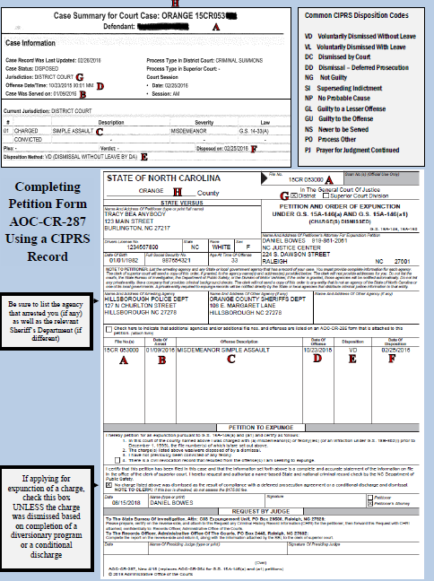
THIS PAGE WILL BE UPDATED WHEN THE NEW FORM IS RELEASED ON DECEMBER 1, 2020.
Please visit ncsecondchance.org/resources for the most up-to-date version of this Summary
How to Read an ACIS Report
Criminal background reports are often difficult to interpret, reflecting the complex nature of criminal proceedings. Particularly hard to interpret are records accessed directly from the North Carolina Court System using the Automated Criminal/Infractions System (ACIS). ACIS records are accessible at each local court house either by request or by using a public terminal (see FAQ 1). ACIS relies on codes and fields that are not intuitive. The picture tutorial below highlights the information and fields relevant to petitioning for an expunction of a criminal charge or conviction. Common ACIS codes are also provided below. On the next page is a petition form completed for the specific criminal record below.
Offense Description
(if conviction)
File Number [NOTE: If “CR” then heard in district court, if “CRS” then superior court]
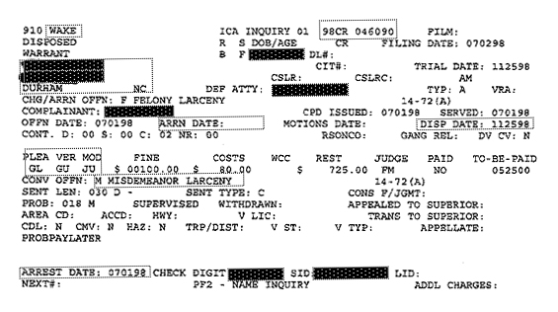
For additional system Code Definitions, see side two of FORM AOC-CR-314, located here: http://www.nccourts.org/Forms/Documents/112.pdf
Common ACIS Abbreviations
CR Criminal District Court
CRS Criminal Superior Court
DC Dismissed by Court
DD Dismissal – Deferred Prosecution
F Felony Offense
M Misdemeanor Offense
I Infraction (non-criminal offense)
GL A Plea or Finding of Guilty to a Lesser Offense
GU A Plea of Finding of Guilty to the Offense
JU Disposed by a Judge
NG Not Guilty
NP No Probable Cause
OF Offense Date
PJ Prayer for Judgment Continued
PO Process/Probation Other
PROB Probation
REST Amount of Restitution Ordered by the Court
SENT Sentence Length Imposed in Months, Days, Years
SI Superseding Indictment
VD Voluntarily Dismissed Without Leave (by DA)
VL Voluntarily Dismissed With Leave (may be Reinstated)
VER Verdict
Date of Offense
Date of
Arrest
Disposition
Name & Address
County of Disposition
Offense Description (if dismissed charge)
Date of Disposition

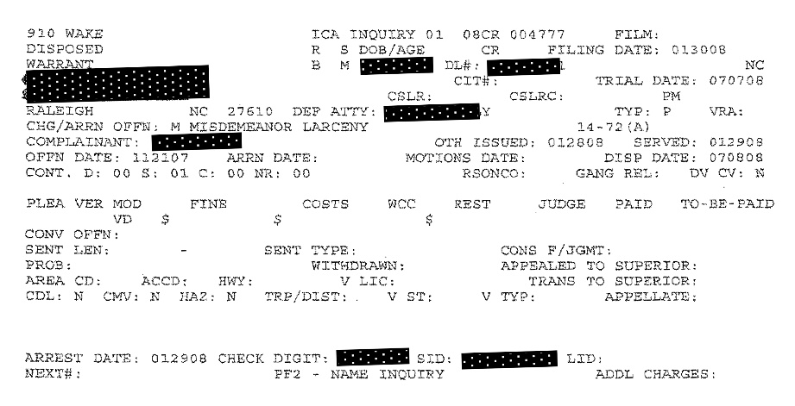
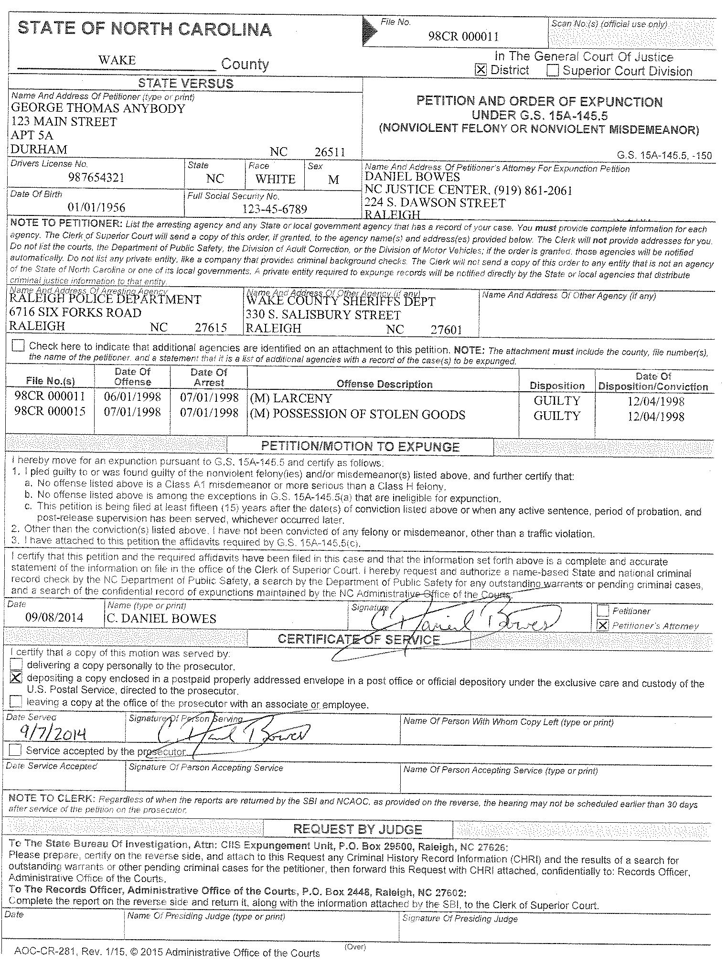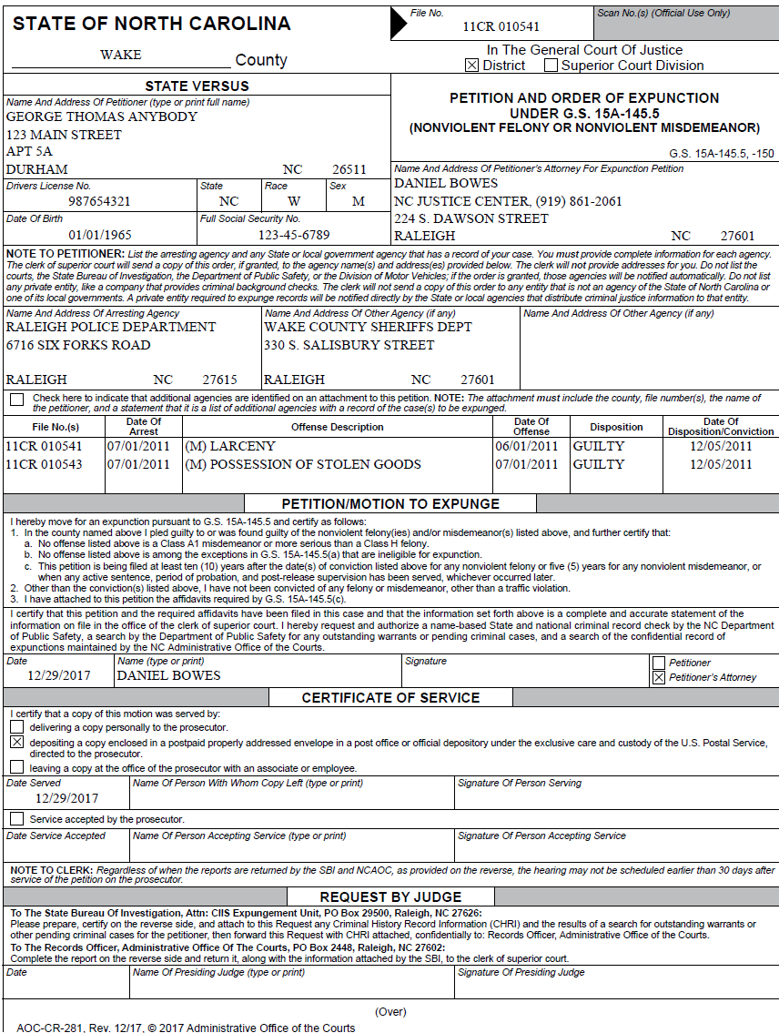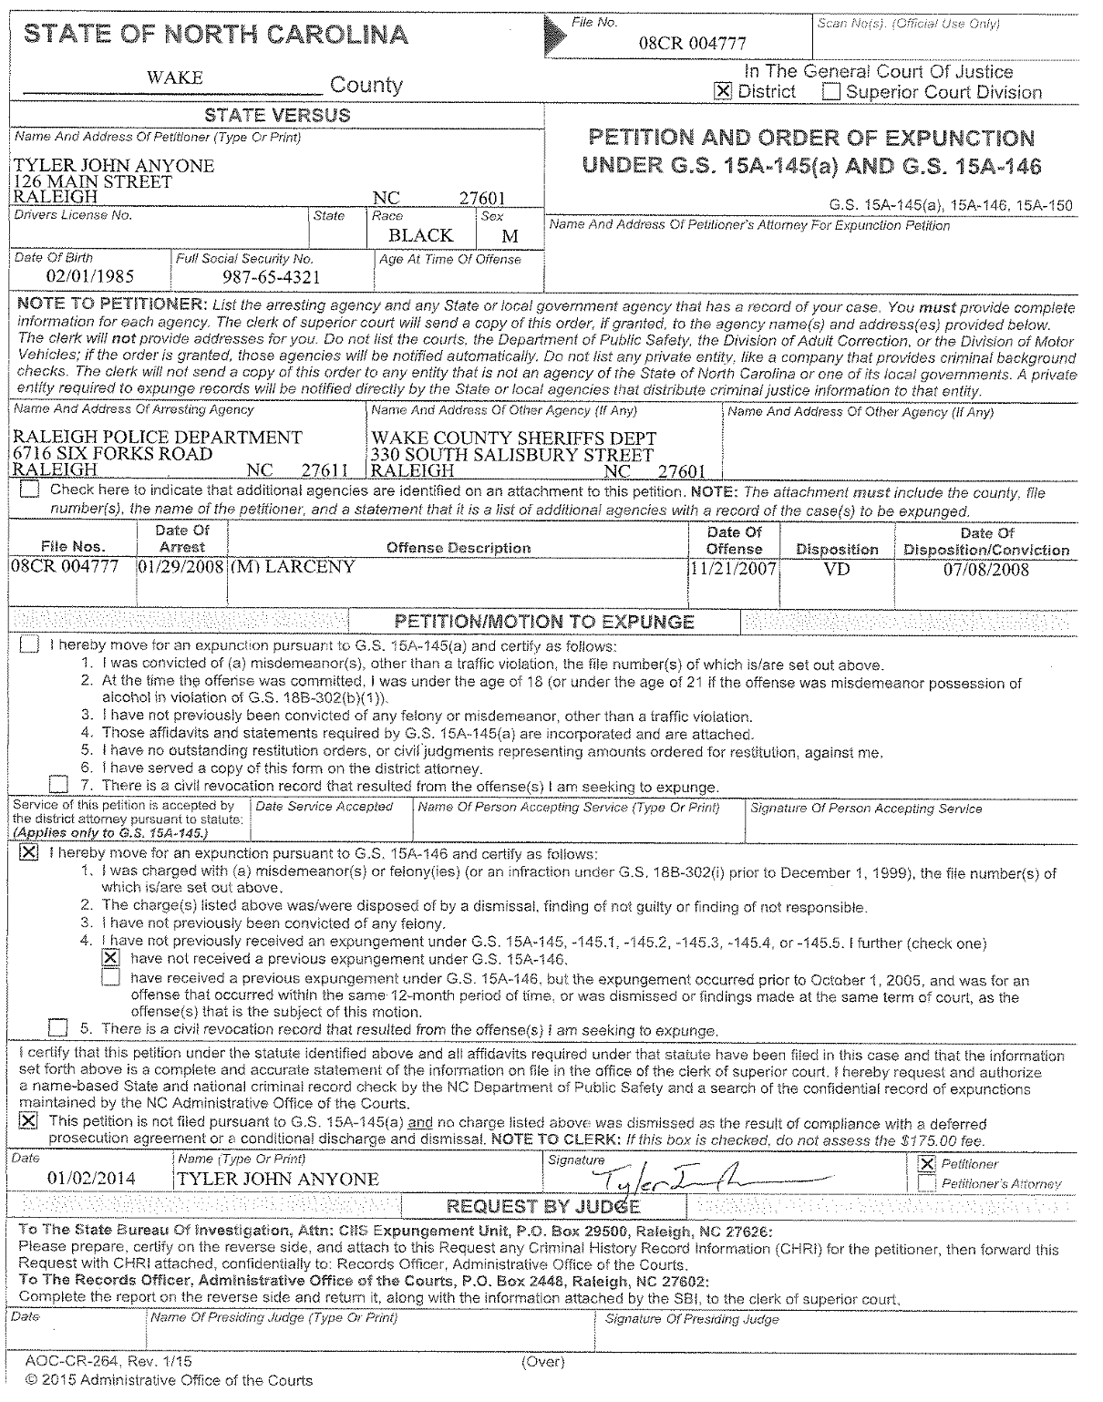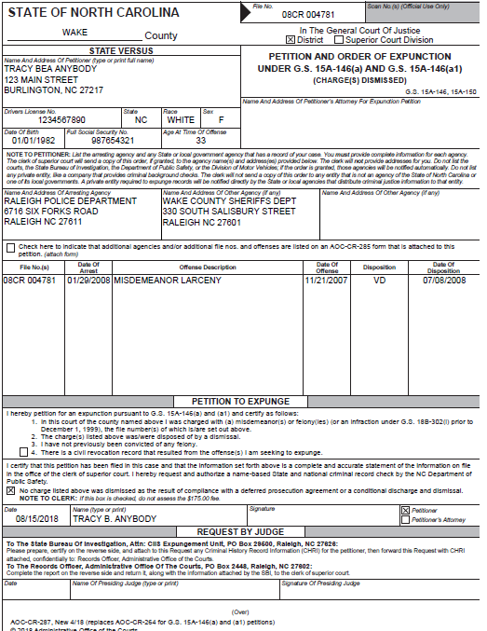
THIS PAGE WILL BE UPDATED WHEN THE NEW FORM IS RELEASED ON DECEMBER 1, 2020.
Please visit ncsecondchance.org/resources for the most up-to-date version of this Summary
NOTE: If applying for expunction of dismissed charge, mark this box unless the charge was dismissed due to completion of a diversionary program or conditional discharge
NOTE: Petition for expunction must be heard in same division (District (CR) or Superior (CRS)) as the original charge’s final disposition. For charge occurring in both divisions, please see FAQ 11.
NOTE: Be sure to include the arresting agency information. It is a best practice to always include the local Sheriff’s Department as they may have records of custody stemming from the arrest/charge.
THIS PAGE WILL BE UPDATED WHEN THE NEW FORM IS RELEASED ON DECEMBER 1, 2020.
Please visit ncsecondchance.org/resources for the most up-to-date version of this Summary
***Petitioner Affidavit WORKSHEET—Please use this as a model for satisfying the statutorily required components of the affidavits specific to each type of expunction. It may be in the best interest of the petitioner to include in the affidavit further attestation and/or explanation of rehabilitation and/or good moral character—Please examine the “Filing Requirements” section (above) for the specific expunction for which petitioner is eligible, as well as the relevant statute. A blank affidavit is provided on the next page.***
NORTH CAROLINA IN THE GENERAL COURT OF JUSTICE
A: Print here the county where the conviction occurred

___[N]______ COURT DIVISION
____[A]_____COUNTY _____[B]______
B: Print here the file number of the conviction. If petitioning for expunction of multiple convictions occurring in the same session of court, place additional file #s beneath this initial line.
Ex. 97 CR 014926
97 CR 014927
97 CR 014928

N: Print “District” or “Superior.” Expunction petition must be heard in the same court in which original disposition occurred. Typically, file no. with “CR” means disposition occurred in District, “CRS” means Superior.

STATE OF NORTH CAROLINA, )
Plaintiff, )
)
) DEFENDANT’S
vs. ) AFFIDAVIT
_________[C]_______________, )
C: Print here Petitioner’s full name.

Defendant. )

NOW COMES the Defendant,_______[C]___________, who, after first being duly sworn,
deposes and says:

- I am the defendant in the above-captioned matter.

- This sworn statement is made in support of my petition to expunge a charge from my criminal record.

- The attached petition is a motion in the cause in the case wherein I was convicted.

- I have been of good moral character and have not been convicted of __[D, E, F, or G- depending on type of expunction—read below]____________________________________________________
D. If seeking expunction under GS 15A-145.5 for a first-time misdemeanor conviction, write in “any other felony, or any other misdemeanor other than a traffic violation.” If seeking expunction under GS 15A-145.5 for multiple misdemeanor and/or one nonviolent felony convictions, write in “any other felony, or any violent misdemeanor.”
E. If seeking expunction under GS 15A-145.6, write in “any felony, or any misdemeanor other than a traffic violation, since the date of the prostitution conviction for which I am petitioning for expungement.”
F. If seeking an expunction under GS 15A-145 or GS 15A-145.1, write in “any felony, or other misdemeanor other than a traffic violation, during the
2-year waiting period.”
G. If seeking an expunction under GS 15A-145.4, write in “any felony, or other misdemeanor other than a traffic violation, during the 4-year waiting period.”

- No restitution orders or civil judgments representing amounts ordered for restitution entered against me are outstanding.
K: Your signature.
L: Print your name.
This the ____[H]____ day of __________[I]_________, 202 [J].
H: Day completed affidavit
(must be same day notarized).
I: Month completed affidavit.
J: Year completed affidavit.

_____________________[K]__________________
________[L]_______, Affiant
Sworn to and subscribed before me
M: A Notary Public will need to complete this portion of the affidavit. For more information on finding a Notary Public, please visit the NC Secretary of State website here: http://www.secretary.state.nc.us/NotaryPublic/Search
on this the __[M]___ day of _____[M]__________, 202_.
__________[M]________________________
Notary Public
My Commission Expires: _____[M]________
NORTH CAROLINA IN THE GENERAL COURT OF JUSTICE
____________ COURT DIVISION
___________COUNTY ________________

STATE OF NORTH CAROLINA, )
Plaintiff, )
) DEFENDANT’S
vs. ) AFFIDAVIT
)
___________________________, )
Defendant. )

NOW COMES the Defendant,_____________________, who, after first being duly sworn,
deposes and says:

- I am the defendant in the above-captioned matter.

- This sworn statement is made in support of my petition to expunge a charge from my criminal record.

- The attached petition is a motion in the cause in the case wherein I was convicted.

- I have been of good moral character and have not been convicted of ____________________ ________________________________________________________________________________________________________________________________________________________________

- No restitution orders or civil judgments representing amounts ordered for restitution entered against me are outstanding.

This the _____ day of ___________________, 202_.

_______________________________________________
_______________________, Affiant

Sworn to and subscribed before me
on this the _____ day of _______________, 202_.

__________________________________
Notary Public

My Commission Expires: _____________

***Affidavit of Good Character WORKSHEET—Please use this as a guide—a blank affidavit is located on the next page***
NORTH CAROLINA IN THE GENERAL COURT OF JUSTICE
A: Print here the county where the conviction occurred

_____[M]________ COURT DIVISION
____[A]___ COUNTY _______[B]________
M: Write “District” or “Superior.” Expunction petition must be heard in the same court in which original disposition occurred. Typically, file no. with “CR” means disposition occurred in District, “CRS” means Superior.

B: Print here the file number of the conviction. If petitioning for expunction of multiple convictions occurring in the same session of court, place additional file #s beneath this initial line.
Ex. 97 CR 014926
97 CR 014927
97 CR 014928

STATE OF NORTH CAROLINA, )
Plaintiff, )
)
vs. ) AFFIDAVIT OF
) GOOD CHARACTER
__________[C]_______________, )
C: Print here Defendant’s full name.

Defendant. )
D: Print here Affiant’s full name.

The Affiant,_________[D]____________________, after first being duly sworn, deposes and says:

- I am a personal acquaintance of the Defendant in the above-captioned matter.

- This statement is in support of the Defendant’s petition to expunge a conviction from his/her criminal record.

- I am not related to the Defendant by blood or marriage, nor am I related to other Affiant ____[E] ______ by blood or marriage.
E: Print here the name of the other affiant who is attesting to the good character of defendant.

- I have known the Defendant for _[F]_ years.
F: Print here the number of years affiant has known defendant.

- I live in the same community as the Defendant.

- I know the character and reputation of the Defendant in the community in which Defendant lives. Defendant’s character and reputation in Defendant’s community are good.
I: Year
This the __[G]___ day of _____[H]__________, 202_[I] .
J: Affiant Signature
K: Affiant Printed Name
G: Day Affiant completed affidavit
H: Month
I: Year
_______________[J]_____________________
_______[K]__________, Affiant
Sworn to and subscribed before me
L: A Notary Public will need to complete this portion of the affidavit. For more information on finding a Notary Public, please visit the NC Secretary of State website here: http://www.secretary.state.nc.us/NotaryPublic/Search

on this the _[L]_ day of ___[L]____________, 202 [L]_.

____________[L]________________________
Notary Public
My Commission Expires: _____[L]___________

NORTH CAROLINA IN THE GENERAL COURT OF JUSTICE
___________ COURT DIVISION
__________ COUNTY ______________ ___

STATE OF NORTH CAROLINA, )
Plaintiff, )
)
vs. ) AFFIDAVIT OF
) GOOD CHARACTER
___________________________, )
Defendant. )

The Affiant,_____________________________, after first being duly sworn, deposes and says:

- I am a personal acquaintance of the Defendant in the above-captioned matter.

- This statement is in support of the Defendant’s petition to expunge a conviction from his/her criminal record.

- I am not related to the Defendant by blood or marriage, nor am I related to other Affiant ______ ______ by blood or marriage.

- I have known the Defendant for ____ years.

- I live in the same community as the Defendant.

- I know the character and reputation of the Defendant in the community in which Defendant lives. Defendant’s character and reputation in Defendant’s community are good.

This the _____ day of _______________, 202_.
____________________________________
_________, Affiant
Sworn to and subscribed before me
on this the __ day of _______________, 202_.

_____________________________________
Notary Public

My Commission Expires: ________________

FREQUENTLY ASKED QUESTIONS
In petitioning for relief under North Carolina’s expunction statutes, the following are frequently asked questions regarding terms, interpretations, and procedures:
- How do I obtain a complete and accurate account of petitioner’s criminal record?
  - Gaining access to a complete and accurate copy of a person’s criminal record is no easy task. There are several avenues to gain access to a criminal record, but each has its pros and cons:
    - County Clerk of Court: A copy of an individual’s criminal record may be obtained at the Clerk of Court’s Office in the county in which he or she was charged with a crime. A criminal record provided by a Deputy Clerk of Court will only contain records of charges or convictions that occurred in that county. A certified copy of a criminal record is usually $25. To access a certified copy of a criminal record, you must submit form AOC-CR-314, located here: http://www.nccourts.org/Forms/Documents/112.pdf. However, most clerks make an “uncertified” copy available for a fraction of that fee.
    - Access to ACIS terminal: Direct access to the ACIS system is available through computer terminals located at local courthouses. Both attorneys and non-attorneys may conduct local and statewide name-based searches through the terminals, but be warned- the ACIS system was developed in 1981 and is notoriously hard to navigate. The Administrative Office of the Courts recently published a “citizen’s guide” to conducting searches of the ACIS system, located here: http://www.nccourts.org/Training/Documents/ACIS_Inquiry_RG.pdf
    - NC State Bureau of Investigation (SBI): An individual may request a copy of his or her statewide criminal record from the NC SBI. The individual must submit a “Right to Review” form, along with a completed fingerprint card. The cost of the request is $14. Sheriff’s departments typically charge $25 to complete a fingerprint card. The “Right to Review” form is accessible here: https://www.ncdps.gov/div/SBI/Forms/SBIRight-to-Review__FILLABLE.doc
    - Adverse Action: When a prospective employer denies employment to a job applicant or otherwise takes “adverse action” based on an applicant’s criminal history, the employer is usually required to provide to the applicant a copy of any criminal background report generated by a commercial provider. For more information, please visit the Fair Credit Reporting Act website here: http://www.consumer.ftc.gov/sites/default/files/articles/pdf/pdf-0096-fair-credit-reporting-act.pdf
    - Commercial Provider: An individual may obtain a criminal background report from a commercial provider at varying prices. These can provide state and federal criminal record information but are often inaccurate.

- How do I identify and obtain the correct petition form?
  - A prospective petitioner or petitioner’s attorney must first determine the specific type of expunction for which a petitioner may be eligible because each type of expunction has a specific petition form. If using a digital version of this summary, one may use the hyperlinks contained under the “Filing Requirements” section for each expunction. Otherwise, one may use the form number (also contained in the “Filing Requirements” section) to obtain the specific petition form from the Clerk of Court’s Office or the Administrative Office of the Court’s (AOC) website, http://www.nccourts.org/forms/formsearch.asp (enter the form number, ex. AOC-CR-264, into the field labeled, “Form Number,” and click “Search”).

- How do I file a completed petition for expunction?
  - A petition for expunction must be filed in the county in which the charge or conviction for which the petitioner is seeking expunction occurred. The petition must be filed with the clerk who will then send the petition to the SBI for a state and national background check. It is up to the local practices whether or not the petitioner or clerk procures a judge’s signature to authorize the NCSBI to conduct the state and national background checks. In order to determine exactly how one should file a petition for expunction in a specific county, petitioner or petitioner’s attorney should speak with a deputy clerk of court in the county. For example, some counties allow a petitioner to submit a petition to the Clerk of Court’s Office once the petitioner has completed the sections requiring biographical information, arresting agency, offense description, and motion to expunge. In those counties, the Clerk of Court will then provide notice to the District Attorney (having them complete the “certificate of service” section of the petition form), obtain the presiding judge’s signature, and mail the completed petition form and any accompanying affidavits to the SBI/AOC. However, in other counties, the petitioner is expected to not only complete the biographical, arresting agency, offense description, and motion to expunge sections, but is also expected to provide notice to the District Attorney (having them complete the certificate of service), and obtain the presiding judge’s signature before submitting the petition to the clerk. Similarly, a few counties require a certified copy of petitioner’s criminal record to be submitted with the petition for expunction (see FAQ 1). That is all to say, whether a petitioner or a petitioner’s attorney, one must learn from the Clerk of Court’s Office the specific procedures for filing a petition for expunction.

- What is the overall process for petitioning for expunction of a criminal record?
  - Typically, a completed petition form is submitted to the Clerk of Court in the county in which the criminal incident giving rise to the criminal record for which petitioner is seeking expunction occurred. The petition is then submitted to the SBI and the AOC. In the past, some counties have required a petitioner to submit the completed petition form directly to the SBI/AOC. Session Law 2017-195 requires petitions submitted after December 1, 2017, to be filed with the clerk who will then send the petition to the SBI. The SBI conducts a state criminal background check and obtains a federal background check from the Federal Bureau of Investigation. The AOC determines and indicates in an attachment to the petition form if the petitioner has previously received an expunction. The petition form and criminal background check are returned to the Clerk of Court’s Office. As of November 2018, this process is taking 2-3 months. Once a petition for expunction is returned to a Clerk of Court’s Office, processes vary widely by county and by type of expunction. In some counties, the petition packet is provided directly to the presiding judge for all expunctions, and an order either granting or denying the petition is issued without a hearing. In other counties, notice is provided to the petitioner or petitioner’s attorney when the packet is returned from the SBI/AOC and he or she is responsible for scheduling (also called “calendaring”) a hearing before the presiding judge. And in yet other counties, the process varies by type of expunction—for example, petitions for expunction of dismissed charges are reviewed without a hearing, while petitions for expunction of nonviolent convictions are scheduled for hearing. Again, petitioner or petitioner’s attorney will need to speak to the staff at the Clerk of Court’s office in order to learn the processes specific to the county in which the petition for expunction is being filed. If an order for expunction is granted, the clerk of court erases the ACIS entry and then delivers a certified copy of the order to the NC Administrative Office of the Courts. Certified copies of the order are also delivered to the identified arresting agencies, the sheriff, the Division of Motor Vehicles, and the Department of Public Safety (both Combined Records and the State Bureau of Investigation’s Expungement Unit), which delete the records from their respective databases. The Department of Public Safety also forwards the expunction order to the FBI.

- What is a certificate of service?
  - Most expunction statutes require notice of the petition for expunction to be provided to the Office of the District Attorney. Accordingly, many of the petition forms have a “certificate of service” section where a representative from the Office of the District Attorney certifies with their signature that the office was properly provided a copy of the petition for expunction. Petitioner should speak to the Clerk of Court’s office to determine the specific procedures for completing the certificate of release. Again, procedures vary by county—some counties, for example, allow the petition to be submitted to the Clerk of Court’s office and the Clerk of Court’s office notifies the DA, while other counties require petitioners to notify the DA. If petitioner or petitioner’s attorney is required to provide notice on the Office of the District Attorney, he or she will need to provide the representative a copy of the petition form and accompanying materials, and then have the representative complete the certificate of service section on the original petition form.

- How do I obtain a copy of an expunction order?
A. Based on the changes to the expunction procedure set forth in Session Law 2017-195, copies of expungement orders are easier to obtain. When the expunction is granted, the clerk is required to provide the petitioner with a certified copy of the expunction order. There should not be an additional fee for this certified copy of the expunction order. The new law also provides a person the ability to obtain verification of the expunction of a criminal record at any time directly from the North Carolina Administrative Office of the Courts. This is a verification that the expunction occurred, rather than a copy of the expunction order itself. In order to obtain a “certificate of verification of prior expunction” the person whose record was expunged may submit form AOC-G-260.

- What if the county of disposition requires there to be a hearing on the petition?
  - As previously mentioned, procedures for submitting a petition for expunction vary by county and type of expunction. So too vary the practices for reviewing the petitions. In many counties, upon their return from the SBI/AOC, petitions are reviewed by a judge without a formal hearing. In these counties, petitioners are not typically informed when the petition is returned from the SBI/AOC and prior to a judge’s review; instead, petitioners are informed only after a judge has granted or denied the petition for expunction. In other counties, petitioners must appear before the court in a formal hearing. In such circumstances, it is very important that the petitioner ask the Clerk of Court how to schedule the hearing on the petition. Such hearings are typically evidentiary, meaning the petitioner is given the opportunity to present evidence and arguments to demonstrate that he or she is eligible for expunction. Most of the expunction statutes require the court to grant the expunction if the client is eligible. However, NCGS 15A-145.5 Expunction of Nonviolent Offenses preserves the court’s discretion to grant or deny the petition, even where the individual is eligible for expunction. If the Office of the District Attorney opposes the petition, they will typically argue against the petition at this hearing.

- What is the procedure for appealing or otherwise challenging an expunction decision?
  - According to the North Carolina Court of Appeals recent decision in State v. J.C., expunctions are a criminal matter, at least for purposes of appeal. For a thorough and thoughtful discussion of the issue, please see the UNC School of Government’s post by Professor John Rubin here: https://nccriminallaw.sog.unc.edu/appeals-expunction-decisions/

- Can an individual have an out-of-state or federal criminal record expunged under North Carolina’s expunction statutes?
  - No. Only charges or convictions occurring under North Carolina law are eligible for expunction under North Carolina’s expunction statutes. Each state has its own statutes related to the expunction and/or sealing of criminal records.

- Will a federal or out-of-state criminal record make an individual ineligible for expunction of charges and/or convictions that occurred in North Carolina and would otherwise be eligible for expunction?
  - Yes, in many circumstances. A conviction under the laws of the United States or other states is treated as an “other felony or misdemeanor conviction” for purposes of expunctions in NC. Accordingly, if a specific expunction statute requires that an individual have “no other convictions,” then a federal or other state conviction will likely make that individual ineligible for relief in North Carolina. In processing each petition for expunction, the SBI obtains a federal background report from the Federal Bureau of Investigation.

- How are Prayers for Judgment Continued (PJCs) treated for purposes of expunction?
  - There is no definitive answer to this question. The generally narrow nature of North Carolina’s expunction relief seems to have impacted the willingness of courts to blur the lines when it comes the nature of PJCs for purposes of expunction. District and superior courts regularly treat PJCs as convictions that are expungeable—meaning a PJC is potentially expungeable under NCGS 15A-145 – 15A-145.6, but is likely not expungeable under NCGS 15A-146 (expunction of dismissed charge). A related question of law is whether a prior or subsequent PJC makes an individual ineligible for expunction of a separate criminal conviction because many expunction statutes require the petitioner to have “no other conviction” or “no previous conviction.” In reviewing petitions in such circumstances, several district and superior courts have been persuaded to treat subsequent or prior PJCs as something other than convictions and not disqualifying, and, thereby, found the petitioners to be eligible for expunctions of the traditional convictions. For more information on expunction of PJCs, please see this article by the UNC School of Government: http://nccriminallaw.sog.unc.edu/?p=1453.

- What are “misdemeanor traffic violations”?
  - Based on the use of the term “traffic violations” in Chapter 20 of the General Statutes, it is likely that a “misdemeanor traffic violation” should be interpreted to mean any misdemeanor offense contained in Chapter 20 of the General Statutes, including DUI. This interpretation has prevailed in several district and superior courts.

- When a charge appears in both District and Superior Courts (most commonly by a superseding indictment or appeal), is it necessary to submit petitions for expunction in both District and Superior Courts?
  - No. In such circumstances, it is only necessary to file the petition for expunction in Superior Court.

- Is the relevant misdemeanor or felony classification for purposes of expunction the classification at the time of the conviction or the current classification of the offense?
  - There is no definitive answer to this question. All misdemeanor and felony offenses are classified for purposes of sentencing. Felonies are classified from A to I, with the most serious offenses being Class A offenses. Misdemeanors are classified A1, 1, 2, and 3, with the most serious offenses being Class A1 offenses and the least serious offenses being Class 3 offenses. Understandably, eligibility for expunction of a criminal conviction is often based on the classification of the offense. However, the expunction statutes are silent as to whether the relevant classification is the classification of the offense at the time of the conviction or the classification of the offense at the time the petition for expunction is submitted. This issue is important because the classification of an offense can change as reforms are made to the law. Such shifts can occur by targeted changes to specific offenses as occurs in every session of the legislature, or, as last occurred in 1994, as part of wholesale reform of our state’s sentencing laws. Accordingly, there will be a handful of circumstances where the classification at the time of conviction and at the time the individual petitions for expunction will be different and the petitioner’s eligibility for expunction will depend entirely upon a court’s interpretation of which classification is relevant. For example, conspiracy to commit armed robbery was a Class H offense in 1993, while conspiracy to commit armed robbery is now a Class E offense—a Class E felony is not eligible for expunction, while a Class H felony may be eligible for expunction. If petitioner would be eligible for expunction under one classification but not the other classification, please reach out to me for a general discussion of this issue at (919) 861-2061.

- At what age are individuals charged as adults in North Carolina?
  - In North Carolina, the juvenile age for misdemeanors and Class H and I felonies increased from 15 to 17 on December 1, 2019, meaning the vast majority of 16- and 17-year-olds accused of crimes in North Carolina will now be treated as juveniles and records of their juvenile adjudications will be treated as confidential. Prior to December 1, 2019, juvenile jurisdiction ended after age 15, meaning individuals accused of criminal offenses were automatically charged as adults beginning at age 16 (note: individuals under age 16 accused of committing certain felony offenses may be charged as adults with the consent of the juvenile court). Accordingly, records of these past charges and/or convictions are not sealed as juvenile adjudications; instead, these charges and/or convictions remain on individuals’ criminal records unless expunged. Section 1 of the Second Chance Act extends broad relief to individuals with these past youthful convictions that would now be treated as juvenile offenses, providing a defendant or the district attorney the ability to petition for relief which the court is required to grant.

- What if an individual has dismissed charges eligible for expunction in multiple counties?
  - The person is eligible to expunge all charges that are dismissed or disposed “not guilty”. Based on the recent change in the law allowing an individual to file multiple petitions for expunction, a person eligible to expunge dismissed charges in separate counties would simply submit separate petitions for each of the charges in the respective counties.

- If an individual receives an order of expunction for a criminal record, what is the likelihood of that criminal record ever showing up again in a criminal background check?
  - When a criminal record is expunged, the record is erased from the records of the court as well as any other state agencies (including the arresting agency). The Administrative Office of the Courts keeps a single file of all expunction orders that is only accessible in very limited circumstances set forth in NCGS §15A-151. Private companies that have contracted with AOC to purchase the information are also required to destroy any expunged records. Companies not doing so are potentially liable for damages under GS §15A-152 (Civil Liability for Dissemination of Certain Criminal History Information). However, more and more cases are arising where the record is being sold or otherwise transferred so far downstream that the records are not being destroyed. Accordingly, there is a significant chance that despite the record being expunged it will at some point appear on a background report. In a circumstance where the expunged record does appear on a criminal background report, the petitioner may lawfully deny the charge or conviction occurred. However, many individuals in this circumstance have found it useful to explain that the criminal record has been expunged by court order.

- Can an employer inquire as to whether an individual has previously received an expunction?
  - According to North Carolina General Statutes §15A-153, a private employer or educational institution “shall not, in any application, interview, or otherwise, require an applicant for employment or admission to disclose information concerning any arrest, criminal charge, or criminal conviction of that applicant that has been expunged.” The statute also explains that an applicant need not answer such unlawful expunction inquiries if they do occur. For more information see here: http://www.ncga.state.nc.us/Sessions/2013/Bills/Senate/PDF/S91v6.pdf.

- What if an individual is not eligible for an expunction of his or her criminal record?
  - Many of the more than 2 million North Carolinians with criminal histories need and are deserving of relief from the collateral consequences of their criminal records. Unfortunately, due to the limited nature of expunction opportunities in NC, most of these individuals will not find meaningful relief under North Carolina’s expunction statutes. The following are potential alternative sources of legal relief:
    - Title VII of the Civil Rights Act of 1964: Title VII prohibits employment discrimination based on race, gender, and other protected classes. While individuals with criminal records are not a protected class, Title VII protections have been partially extended to minorities with criminal records based on a disparate impact theory. For guidance on these protections, please visit here: http://www.eeoc.gov/laws/guidance/arrest_conviction.cfm. To learn more about filing a Title VII charge of discrimination, please visit here: http://www.eeoc.gov/employees/charge.cfm
    - Title VIII of the Civil Rights Act of 1964: Title VIII prohibits housing discrimination based on race, gender, and other protected classes. While individuals with criminal records are not a protected class, Title VIII protections have been partially extended to minorities with criminal records based on a disparate impact theory. For information on how to file a complaint with the US Department of Housing and Urban Development, please see here: http://portal.hud.gov/hudportal/HUD?src=/program_offices/fair_housing_equal_opp/complaint-process
    - Fair Credit Reporting Act: Employer and landlord use of criminal background checks are often regulated under the Fair Credit Reporting Act. For more information please visit here: http://www.consumer.ftc.gov/sites/default/files/articles/pdf/pdf-0096-fair-credit-reporting-act.pdf
Do you have general questions or comments? Please feel free to reach out to Daniel Bowes at danielb@ncjustice.org or Laura Holland at Laura@ncjustice.org.
Updated on 9/29/2020. The most current Summary of North Carolina Expunctions can always be downloaded at https://ncsecondchance.org/all-resources/.

